**Creating Microservices for account and loan**

**CODE:**

**AccountApplication.java:**

package com.cognizant.account;

import org.springframework.boot.SpringApplication;

import org.springframework.boot.autoconfigure.SpringBootApplication;

@SpringBootApplication

public class AccountApplication {

public static void main(String[] args) {

SpringApplication.*run*(AccountApplication.class, args);

}

}

**AccountController.java:**

package com.cognizant.account.controller;

import org.springframework.web.bind.annotation.GetMapping;

import org.springframework.web.bind.annotation.PathVariable;

import org.springframework.web.bind.annotation.RestController;

@RestController

public class AccountController {

@GetMapping("/accounts/{number}")

public Account getAccount(@PathVariable String number) {

return new Account(number, "savings", 234343.0);

}

static class Account {

public String number;

public String type;

public double balance;

public Account(String number, String type, double balance) {

this.number = number;

this.type = type;

this.balance = balance;

}

}

}

**OUTPUT:**

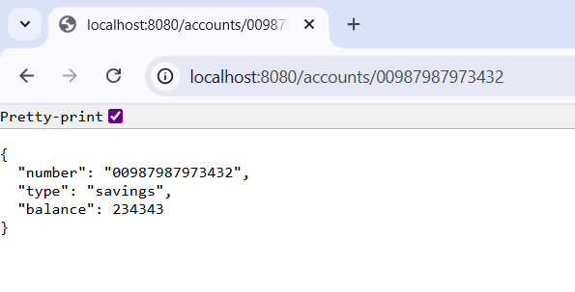

**CODE:**

**LoanApplication.java:**

package com.cognizant.loan;

import org.springframework.boot.SpringApplication;

import org.springframework.boot.autoconfigure.SpringBootApplication;

@SpringBootApplication

public class LoanApplication {

public static void main(String[] args) {

SpringApplication.*run*(LoanApplication.class, args);

}

}

**LoanController.java:**

package com.cognizant.loan.controller;

import org.springframework.web.bind.annotation.GetMapping;

import org.springframework.web.bind.annotation.PathVariable;

import org.springframework.web.bind.annotation.RestController;

@RestController

public class LoanController {

@GetMapping("/loans/{number}")

public Loan getLoan(@PathVariable String number) {

return new Loan(number, "car", 400000, 3258, 18);

}

static class Loan {

public String number;

public String type;

public double loan;

public double emi;

public int tenure;

public Loan(String number, String type, double loan, double emi, int tenure) {

this.number = number;

this.type = type;

this.loan = loan;

this.emi = emi;

this.tenure = tenure;

}

}

}

**OUTPUT:**

